PRACTICAL SUBMISSION RECORD- A.Y. 2025-26
Class: SYMCA Div.: B  Semester: III | Course Code: MCA01604  Course Name: Data Science Laboratory |  | Batch: S1
Name: Tejashree Vijay Dumasia |  | Roll No: 52117
CO No: CO605.1 |  | Assignment No: 6

Title: Load the tissue_gene_expression dataset. Run a k-means clustering on the data with K=7. Make a table comparing the identified clusters to the actual tissue types. Run the algorithm several times to see how the answer changes.
Code:-
import pandas as pd
import matplotlib.pyplot as plt
import seaborn as sns
from sklearn.cluster import KMeans
from sklearn.decomposition import PCA
from sklearn.preprocessing import StandardScaler

try:
df = pd.read_csv('tissue_gene_expression.csv')
print("✅ CSV file loaded successfully.\n")
except FileNotFoundError:
print("❌ FATAL ERROR: The file 'tissue_gene_expression.csv' was not found.")
print("Please make sure you have successfully converted the .rda file first.")
exit()

X = df.drop('tissue', axis=1)
y_true = df['tissue']

kmeans = KMeans(n_clusters=7, random_state=42, n_init=10)
y_kmeans = kmeans.fit_predict(X)

print("--- Comparison of Actual Tissues vs. K-Means Clusters ---")
comparison_table = pd.crosstab(y_true, y_kmeans, rownames=['Actual Tissue'], colnames=['Assigned Cluster'])
print(comparison_table)
print("\n" + "="*60 + "\n")

print("--- Generating Visualization ---")
scaler = StandardScaler()
X_scaled = scaler.fit_transform(X)

pca = PCA(n_components=2)
X_pca = pca.fit_transform(X_scaled)

pca_df = pd.DataFrame(data=X_pca, columns=['Principal Component 1', 'Principal Component 2'])
pca_df['Actual Tissue'] = y_true
pca_df['K-Means Cluster'] = y_kmeans

plt.style.use('seaborn-v0_8-whitegrid')
fig, axes = plt.subplots(1, 2, figsize=(16, 7), sharex=True, sharey=True)
fig.suptitle('K-Means Clustering vs. Actual Tissue Types (Visualized with PCA)', fontsize=16)

sns.scatterplot(
ax=axes[0],
data=pca_df,
x='Principal Component 1',
y='Principal Component 2',
hue='Actual Tissue',
palette='deep',
s=60,
alpha=0.8
)
axes[0].set_title('Colored by Actual Tissue (Ground Truth)')
axes[0].legend(loc='best')

sns.scatterplot(
ax=axes[1],
data=pca_df,
x='Principal Component 1',
y='Principal Component 2',
hue='K-Means Cluster',
palette='viridis',
s=60,
alpha=0.8
)
axes[1].set_title('Colored by K-Means Cluster')
axes[1].legend(loc='best')

plt.tight_layout(rect=[0, 0, 1, 0.96])

print("✅ Plot is being displayed in a new window.")
plt.show()
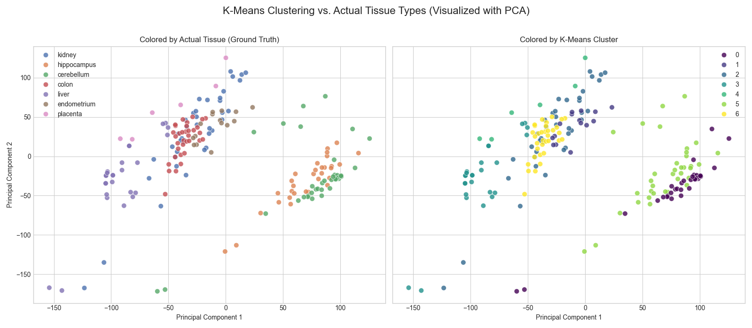 Output:-

